Development of a Comprehensive Property Management and Investment Analysis Platform

Project Plan

[PropertyPro Tech Team]

Name | Position | email | phone
Dhruvil Savani | Authentication Lead | 104644017@student.swin.edu.au | 0451565356
Om Patil | Property Management Lead | 104682059@student.swin.edu.au | 0414139651
Mahesh Gujjer | Dashboard & Portfolio Lead | 104335913@student.swin.edu.au | 0424417986
Dhruv Goti | Documantation | 104851765@student.swin.edu.au | 0468415123
Sammit Raut | Tax & Simulation |  | 0488163904

SUBJECT CODE: COS80029
NAME: Technology Application Project
SEMESTER AND DATE: Semester 1 And 6 April 2025

Content

Document Change Control 3
Document Sign Off 3
Client Sign off 3
1. Introduction 4
1.1. Background 4
1.2. Key Project Personnel 4
1.2.1. Client 4
1.2.2. Other Stake holders 4
1.2.3. Project Supervisor, Team Leader and Key Project Members 4
2. Terms of Reference 5
2.1. Objectives 5
2.2. Scope 5
2.3. Critical Success Factors 5
2.4. Acceptance Criteria 5
3. Establishment 6
3.1. Processes, Procedures and Standards 6
3.2. Project Environment 6
3.3. Project Team Skill Development Requirements 6
4. Deliverables, Activities and Capital Resources 7
4.1. Deliverables 7
4.2. Activities 7
4.3. Resources 7
5. Organisation and Structure 8
6. Risks 9
7. Schedule 10
7.1. Project Time Line 10
7.2. External Dependencies 10
7.3. Assumptions 10
8. Budget 11
9. References 12
10. Tables Index 12

Document Change Control

Version | Date | Authors | Summary of Changes
1.0 | 2025-03-15 | Dhruv Goti | Initial draft of the project concept
1.1 | 2025-03-22 | Om Patil | Added property management objectives
1.2 | 2025-03-28 | Mahesh Gurjar | Updated dashboard metrics and UI details
1.3 | 2025-04-02 | Sammit Raut | Integrated tax simulation module details
1.4 | 2025-04-04 | Dhruvil Savani | Finalized authentication and security notes

Document Sign Off

Name | Position | Signature | Date
 | Documentation & Integration | Dhruv Goti | 2025-04-06
Om Patil | Property Management Module Developer | Om patil | 2025-04-06
Mahesh Gurjar | Dashboard & Analytics Developer | Mahesh Gurjar | 2025-04-06
Sammit Raut | Tax & Simulation Developer | Sammit Raut | 2025-04-06
Dhruvil Savani | Auth & Security Developer | Dhruvil Savani | 2025-04-06

Client Sign off

Name | Position | Signature | Date
Sadi Shaik
Organisation
[Client to sign off on the Project Plan to signify they agree with the plan]

Introduction

The Comprehensive Property Management and Investment Analysis Platform project plan is described in this paper. For team members, the project manager, and the client, among others, it acts as a guide. The project goals, team roles, schedules, risks, and other essential elements for successful completion are all covered in full in this document.

Background

An all-in-one platform is necessary for landlords to simplify rent collecting, financial reporting, tax preparation, and investment research due to the growing complexity of operating investment properties. Using a user-centered design approach and contemporary web technology, this project was started to satisfy this market demand. With the help of Flask, Next.js, and MongoDB, the five-developer team hopes to create a responsive web and Android platform.

Key Project Personnel
The key personnel involve in this project are as follows:

Client
A simulated entity known as the client represents real estate investors who need an intelligent and safe platform to efficiently manage their real estate holdings. As the client's representative, academic supervisors will provide guidance for feedback.

Other Stake holders
- University Supervisor – Academic guide responsible for marking and project oversight.
- Target Users – Property investors, landlords, and property managers.
- Ethics Committee (if applicable) – For questionnaire or interview approvals.

Project Supervisor, Team Leader and Key Project Members

Name | Role
Om Patil | Property Management Developer
Dhruvil Savani | Auth & Security Developer
Sammit Raut | Tax & Scenario Simulation Dev
Dhruv Goti | Documentation
Mahesh Gujjer | Dashboard & Analytics Developer

Terms of Reference

For landlords and investors, this initiative seeks to develop a digital solution that improves property management's efficacy and efficiency. It is intended for landlords who oversee one or more investment properties.

Objectives

Create a safe authentication system for managing sessions and user logins.
Create an interface for property management that supports CRUD functions.
Include computerized financial reporting and tax calculators.
For the purpose of visualizing financial performance, offer an interactive dashboard.
To model "what-if" investment possibilities, incorporate simulation techniques.
Make sure the platform is accessible and responsive on both Android and the web.
Integrate error-handling and data validation across the platform.
Securely store all user data with MongoDB and secured APIs.

Scope
In-Scope:
- Secure login/signup
- CRUD property management
- Tax and scenario simulation
- Investment analytics and reporting
- Dashboard visualizations
- MongoDB backend with Flask APIs
- Frontend with Next.js (React + TypeScript)
Out-of-Scope:
- Full production deployment
- Real-time banking API integration (simulated only)
Start Date: March 15, 2025
End Date: June 10, 2025

Critical Success Factors

Every module of the software must pass functional tests.
Every user input must undergo safe client and server-side validation.
Results from simulations must have a manageable margin of error.
The application ought to function on contemporary browsers.
A user manual and clear documentation must be supplied.

Acceptance Criteria

The degree to which this software solution satisfies the project's goals and essential success criteria, as well as formal acceptance testing protocols, will determine its acceptance.
Functional Testing: If all essential features—like login, session management, property CRUD operations, and dashboard metrics—are working properly and free of serious errors, the client will accept the app. The specified unit and integration test cases must be passed by these functions.
Data Export Validation: During testing, it is necessary to completely implement and examine the capability of exporting property investment summaries as downloadable PDFs. The information in the PDFs must correspond to the information shown in the system.

Front-end and back-end validation must be included in all input forms throughout the system to stop inaccurate, partial, or invalid data from being submitted.
Calculation Accuracy: Analyses of the dashboard's cash flow, ROI, LVR, and other metrics must correspond to carefully confirmed computations. The group will use test datasets and spreadsheets to cross-check the results.
Stakeholder evaluation and Sign-off: A final evaluation will be conducted by the academic supervisor and the fictitious client. They have to verify that every feature operates as specified in the documentation and that the system satisfies user testing-based usability standards.

2.5 Ethical Considerations in User Research
The PropertyPro team recognises and adheres to the National Statement on Ethical Conduct in Human Research 2023 in all user research and requirement elicitation activities. The following ethical measures have been implemented:
- Informed Consent: All participants in interviews, surveys, or usability testing will be provided with a plain language statement and consent form.
- Anonymity and Confidentiality: Participant identities and any data collected will be anonymised and securely stored.
- Inclusivity: Survey and interview questions are designed to be neutral, inclusive, and free from any cultural or social bias.
- Voluntary Participation: All participation is voluntary, with the option to withdraw at any stage without consequence.
- No Real Financial Data: Only fictional scenarios and mock financial datasets are used during requirement elicitation and testing.
These practices ensure the project remains ethically sound while collecting valuable user insights to guide design and development.

Establishment

Processes, Procedures and Standards

The team has chosen to use the Agile development technique for this project. This was selected because it is incremental and iterative, providing for flexibility, rapid feedback response, and ongoing value delivery. To assess progress and make any adjustments, the team will work in weekly sprints, each of which will conclude with review meetings and scheduled retrospectives.
Version Control: The project's codebase is managed using GitHub. After passing code reviews, the feature-specific branches that each developer works in are combined into a protected main branch. Teamwork, traceability, and code quality are all guaranteed by this procedure.
User-Centered Design Process: Figma-based wireframes are the first step in the project's UCD methodology, which is reviewed and iterated upon in response to early user input.

Documentation Standards: Markdown files (README) in GitHub are used for developer and API references, while Google Docs is used for collaboration on project documentation. Consistent formatting standards will be followed for all important deliverables, including setup instructions, user manuals, and test results.
Standards for Code:
The Flask/Python backend adheres to PEP8 standards and uses code linters to ensure uniformity.
Frontend (Next.js/TypeScript): Follows ESLint guidelines and formats using Prettier. Form validation is done using React Hook Form with Zod.
Throughout the project lifetime, these procedures guarantee that the codebase is readable, maintainable, and simple for team members to contribute to.

Project Environment

The project's development and deployment environments are made to facilitate easy teamwork, effective testing, and a flawless web application launch.
Workplaces: Team members use personal development setups to work remotely. Cloud platforms such as GitHub and Google Workspace are used for collaborative work.
Environments for Development:
Every team member uses Visual Studio Code as their main Integrated Development Environment (IDE) for authoring and debugging code.
The main version control repository, GitHub, makes sure source code is accessible and managed appropriately.
Platforms of Deployment:
The Next.js-built frontend application is deployed via Vercel. It enables frontend change preview environments and continuous deployment.
The Flask backend server is hosted by Render, enabling external access and API testing while the project is being developed.

Databases:
All project-related data, such as user profiles, property information, financial records, and simulation results, are stored in MongoDB Atlas, a fully managed cloud database.
Accounts on the server:
Using the project manager's login information, accounts have been created for Vercel, Render, and MongoDB Atlas and safely distributed to the team. Environment variables and access control are set up for security.
Accounts of Users:
Every team member collaborates on the project repository and has their own GitHub account. Additionally, design assets and task tracking are managed using Figma and Trello accounts, respectively.
Additional Tools:
During backend development, Postman is used to test API endpoints.
Trello is a project management application that facilitates task organization, responsibility assignment, and deadline monitoring.
Notion serves as a knowledge store and team wiki for recording sprint updates, reference materials, and internal conversations.
Infrastructure and Stationery:
There is no need for actual stationery because this project is digital-first. Cloud-based solutions like Google Docs and Notion are used to organize all of the notes and paperwork.

Project Team Skill Development Requirements

Sammit: Study tax policy and bracket rules for income, CGT, and stamp duty
Dhruvil: Learn about JWT-based token storage and verification methods
Om: Gain expertise in form validation using React Hook Form and Zod
Mahesh: Understand chart rendering using Recharts and MongoDB aggregation
All: Get comfortable with RESTful API testing and version control workflows

Deliverables, Activities and Capital Resources

Deliverables

A useful web application
a comprehensive platform for investment research and property management that is available through contemporary web browsers. Financial simulations, tax computations, property tracking, and user identification will all be supported.
Last Presentation and Video Demonstration
A brief yet interesting film that explains the platform's key functions and demonstrates how it meets user needs. It will be used to describe project functionality to assessors during the final submission.
Results of Unit and Integration Tests
a report that includes the test scripts, test cases, and results of their execution for both standalone modules and integrated features. This guarantees that the program satisfies functional requirements and functions properly across all components.

documentation for APIs
All backend endpoints (HTTP methods, parameters, answers, and authentication needs) are covered in detail. This will make it easier for evaluators or future developers to comprehend how to use the backend services.
Repository of Source Code and Versioning Log
The complete codebase is organized into frontend and backend directories in the GitHub repository. The branch structure and commit history will demonstrate the version control and collaboration techniques applied during development.
Setup instructions and the user manual
An easy-to-read guide that describes how to use the platform, including how to create an account, manage properties, see dashboards, export reports, and utilize the simulation tool. The project can be deployed locally or in the cloud with the aid of the setup guide.

Activities

- Planning & Design (Weeks 1–2)
  - Tasks:
    - Conduct requirement analysis to clearly define the scope.
    - Create wireframes for all modules using Figma.
    - Assign tasks based on team member expertise.
    - Set up the GitHub repository and Trello board for task tracking.
- Module Development (Weeks 3–8)
  - Tasks:
    - Develop individual modules in parallel:
      - Authentication (Dhruvil)
      - Property Management (Om)
      - Dashboard Analytics (Mahesh)
      - Tax & Simulation Tools (Sammit)
    - Set up backend API routes using Flask.
    - Connect modules with MongoDB database using Mongoose-like schemas.
    - Validate inputs using React Hook Form and Zod.
- Integration & Testing (Weeks 9–10)
  - Tasks:
    - Merge all frontend and backend modules into a unified project structure.
    - Conduct unit tests for individual functions and components.
    - Run integration tests to ensure proper data flow between frontend and backend.
    - Test for edge cases and fix bugs found during validation.
    - Use Postman to test and document backend APIs.
- Finalization (Weeks 11–12)
  - Tasks:
    - Refine UI and improve user experience across devices.
    - Conduct User Acceptance Testing (UAT) with stakeholders.
    - Finalize the documentation including user manual and API guide.
    - Record final demonstration video and prepare the project presentation.
    - Submit all deliverables for evaluation.

Resources

• GitHub (code collaboration)
• MongoDB Atlas (cloud database)
• Figma (UI design)
• Render and Vercel (deployment)
• Laptops, internet, and shared storage (basic infrastructure)

Organisation and Structure
The project is organized using a matrix structure, meaning each team member is responsible for their specific development module but also contributes to system-wide tasks such as testing, integration, and documentation. This structure ensures high accountability, modular development, and cross-collaboration.

Groups Involved:
- Development Team: Core developers responsible for building, testing, and integrating the system.
  - Om Patil – Property Management Module
  - Dhruvil Savani – Authentication Module
  - Mahesh Gujjer – Dashboard & Analytics Module
  - Sammit Raut – Tax and Simulation Module
  - Dhruv Goti – Project Management, Coordination, and Integration
- Supervisor/Client: Acts as the simulated client and provides regular reviews, requirement clarifications, and final sign-off on the deliverables.
- Test Users (End Users/Stakeholders): Represent real-world landlords and business users. They participate in interviews, usability evaluations, and user acceptance testing. Their feedback helps validate system design, user interface effectiveness, and business value.
- Stakeholder Interview Participants: Academic peers or faculty members who contribute insights during requirement elicitation and assist in validating whether ethical, user-friendly, and functional requirements are fulfilled.
This organizational model promotes shared responsibility and effective communication between groups, ensuring each deliverable is supported by both technical and end-user perspectives.
Activities | Deliverables (from 4.1) | Group Involved (as identified above)
CRUD property | Property module | Om
Auth System | Login module | Dhruvil
Dashboard | Metrics & UI | Mahesh
Simulations | Tax tools | Sammit
Docs/Test | Reports & video | All

Table 1 Activities and Deliverables

Risks

The following risks have been noted as having the potential to impact the project's quality and progress. The main operational risks are included, along with practical mitigation techniques and backup plans, even if this is not a comprehensive risk management system. The possibility and seriousness of each danger are taken into consideration.

Rank | Name/Description | Occurrence Probability | Severity | Mitigation Strategy | Contingency Plan
1 | Team member unavailable | Medium | High | Assign a backup member for each module(Strategy 1) | Reallocation tasks and extend deadline if needed
2 | Hosting platform failure | Low | High | Use both platforms in parallel for redundancy(Strategy 2) | Host locally or switch to alternate free-tier
3 | Incorrect tax calculation logic | Medium | High | Validate formulas with official ATO(Strategy 3) | Temporarily disable affected feature and notify users
4 | Integration conflicts between modules | Medium | Medium | Schedule mock integration sessions during sprints (Strategy 4) | Use modular fallback UI or disable feature temporarily
5 | Delay in receiving supervisor/client feedback | Medium | Medium | Schedule regular check-ins and keep updated logs (Strategy 5) | Proceed with assumptions and retroactively adjust
6 | Inconsistent design across modules | Medium | Medium | Define shared UI design system using Figma components (Strategy 6) | Harmonize UI at integration stage

Table 2 Risks

7. Schedule

7.1. Project Time Line

Week | Activity | Members
1-2 | Requirements, Wireframing | All
3-5 | Frontend and backend dev | All
6-8 | Feature completion and unit testing | All
9-10 | Integration, bug fixes | All
11-12 | UAT, Documentation | All

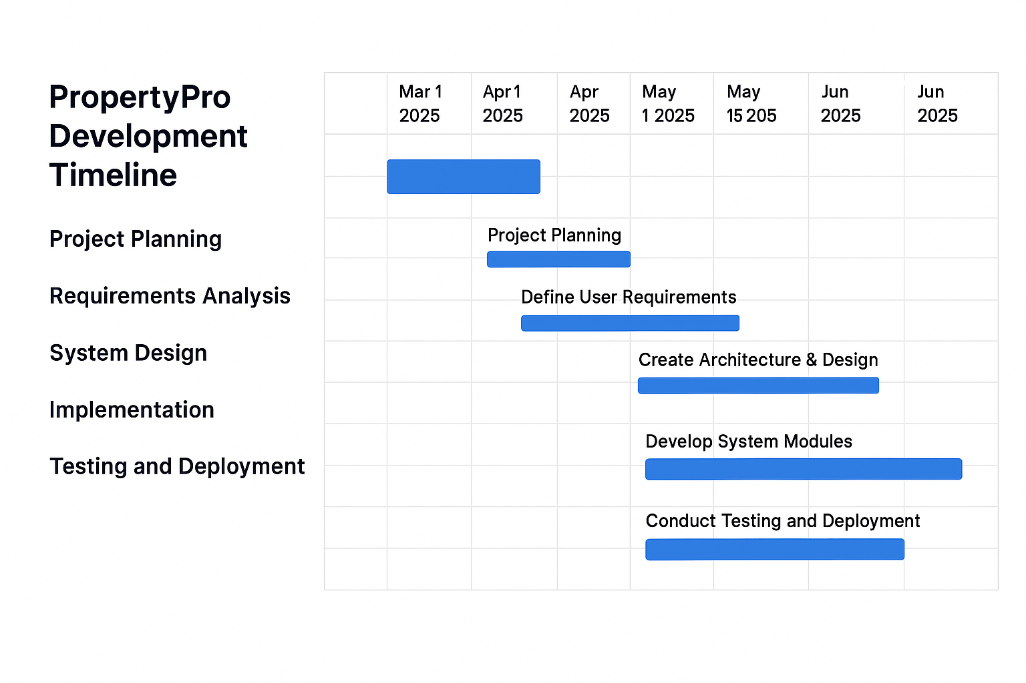
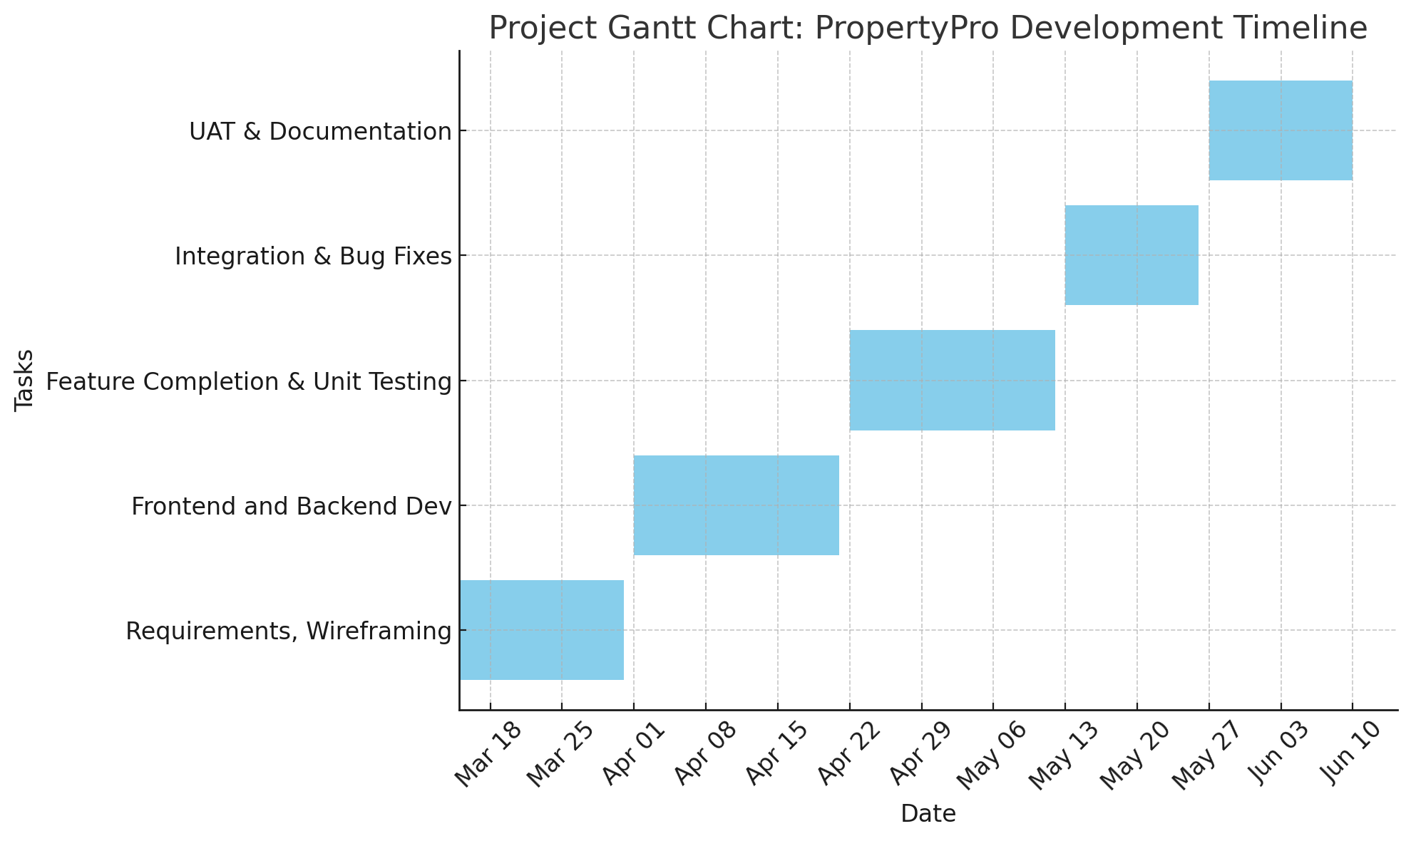

External Dependencies
- Data from the Australian Taxation Office
- Deployment uptime of Render and Vercel
- Stable access to MongoDB Atlas

Assumptions

When creating the project schedule and resource planning, the following presumptions were made:
Every team member is available and has the necessary abilities to finish their modules on schedule without assistance from outside sources.
Stable internet connectivity, cloud service credits (for example, Render, Vercel, and MongoDB Atlas), and the software tools required to enable the development environment must all be provided by the university.
It is anticipated that during Week 11, stakeholders—including the peer evaluators and academic supervisor—will be ready to take part in User Acceptance Testing (UAT).

- Budget

Personnel Cost

Name | Hourly Rate
Dhruv | $25
Dhruvil | $35
Om | $36
Mahesh | $32
Sammit | $34

Table 2 Personnel Cost
Time Estimated to Complete Each Task

Activity | Task | Estimated Hours | Total Hours
Auth Module | Login system, tokens | 40 | 40
Property Module | Forms and API | 45 | 45
Dashboard | Charts and metrics | 50 | 50
Simulation/Tax | Tax logic and UI | 55 | 55
Testing & Docs | Reports and videos | 30 | 30
 |  | Total | 220

Table 3 Task time estimate

8. Intellectual Property and Attribution
All digital assets, software libraries, and open-source tools used in the development of PropertyPro are properly attributed and comply with intellectual property laws and Swinburne's Academic Integrity Policy. Below is a summary of usage:
- UI Design: All user interface components are designed in Figma. Any external UI kits or assets used are either original or attributed according to their licenses.
- Software Libraries: Key libraries include React Hook Form, Zod, Recharts, and MongoDB Atlas, all used under permissive licenses such as MIT.
- Documentation and Code: All documentation, diagrams, and code are original or adapted with proper credit. No proprietary material is used without permission.
- Attribution Method: Attributions are listed in source code comments, user manuals, and the project documentation folder.
The team commits to transparency, originality, and legal compliance in all content delivered as part of the solution.

References
- Australian Taxation Office 2024, Income tax rates for individuals, Australian Government, viewed 4 April 2025, https://www.ato.gov.au/rates/individual-income-tax-rates/.
- Australian Taxation Office 2024, Capital gains tax – real estate, Australian Government, viewed 4 April 2025, https://www.ato.gov.au/individuals/capital-gains-tax/property/.
- MongoDB Inc. 2024, MongoDB Atlas Documentation, MongoDB, viewed 4 April 2025, https://www.mongodb.com/docs/atlas/.
- Vercel Inc. 2024, Deploying Next.js apps, Vercel, viewed 4 April 2025, https://vercel.com/docs.
- Render 2024, Getting Started with Flask on Render, Render, viewed 4 April 2025, https://render.com/docs/deploy-flask.
- React Hook Form 2024, Getting Started, React Hook Form, viewed 4 April 2025, https://react-hook-form.com/get-started.
- Yates, J 2009, Tax expenditures and housing, Australian Housing and Urban Research Institute, viewed 4 Apr, http://www.ahuri.edu.au/publications/download/ahuri_judith_yates_research_paper.

